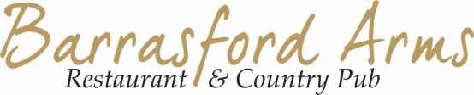

LUNCH TIME & EARLY BIRD SPECIAL 12-2PM & 5.30-6.30PM
One Course £12.00 || Two Courses at £16.50 || Three Courses at £19.50

STARTERS
Tomato Soup, Basil & Olive Oil
Barrasford Arms Twice Baked Cheddar Cheese Souffle
Pickled & Roast Heritage Beetroot, Goats Cheese & Horseradish Cream

MAIN COURSE
Pork Belly, Side of Cream Sauce, Black Pudding Mash & Roasted Carrots
Barrasford Arms Beef Burger, Cheddar Cheese, Gem Lettuce, Tomato, Hand Cut Fries & Burger Sauce
Hake & Salmon Fishcake, Poached Egg & Chive Butter Sauce

DESSERTS
Classic Fruit of the Forrest Eton Mess
Sticky Toffee Pudding, Butterscotch Sauce & Pouring Cream
Drambuie & Raspberry Crème Brulee

